MACHİNE LEARNİNG
“Midterm Project Report”

Ravza KOÇ
24040102023
10.11.2026

1.Loading the Datasets
In this project I used two datasets from scikit-learn: Breast Cancer Wisconsin (load_breast_cancer) and Wine (load_wine). For each dataset I separated the features (X) and the target (y), and I made X a pandas DataFrame with the original feature names. I did not put the target inside X. In Breast Cancer, each row is a patient and the features are measurements of cell nuclei from a breast mass. The target shows if the mass is malignant (0) or benign (1). I kept the original labels and I used class 0 (malignant) as the positive class. In Wine, each row is a wine and the features are chemical measurements. The target shows which of three grape types the wine comes from (class 0, 1, 2). Table 1 shows a short overview of both datasets.
Dataset | Samples | Features | Classes | Class counts
Breast Cancer | 569 | 30 | 2 (0 = malignant, 1 = benign) | 212 / 357
Wine | 178 | 13 | 3 (class 0, class 1, class 2) | 59 / 71 / 48

2. Dataset Quality Checks
I checked both datasets before using them. There were no missing values in any column and there were no duplicate rows in both datasets. So I did not fill or delete anything.
All features are numbers. Breast Cancer has 30 numerical features and Wine has 13 numerical features. There are no categorical features, so I did not change any data type.
To find possible outliers I used the IQR method. For each feature, values smaller than Q1 - 1.5 x IQR or bigger than Q3 + 1.5 x IQR are counted as outliers. In Breast Cancer, the area columns had the most outliers. In Wine, magnesium and alcalinity_of_ash had the most outliers (4 each). Most outliers were on the big side.
I did not delete these values. They may not be mistakes. For example, malignant tumors can really have bigger cells, and some wines can really have different chemical values. But outliers can affect some models. KNN and K-Means use distance, so very big values can change the result a lot. Naive Bayes uses the mean and spread of each class, so it can also be affected a little. Decision Tree is not affected much, because it only checks if a value is bigger or smaller than a limit.

3. Exploratory Data Analysis (EDA)
3.1 Descriptive statistics
I calculated the mean, median, minimum, maximum, standard deviation, Q1 and Q3 for every feature. The full tables are in the Appendix. The main thing I saw is that the features have very different scales. In Breast Cancer, mean area is in the hundreds and thousands, but mean smoothness is around 0.1. In Wine, proline is around 750 on average and can go up to about 1680, magnesium is around 100, but hue and ash are between 0 and 3. Because of this, models that use distance (KNN and K-Means) can be controlled by the big features. This is the reason I used scaling in Section 5. In some features, like mean area in Breast Cancer and proline in Wine, the mean is bigger than the median. This means a few samples have very big values.
3.2 Class distribution and correlations
In Breast Cancer there are 212 malignant and 357 benign samples, so benign is more common. In Wine the class counts are 59, 71 and 48, so the classes are more balanced. Because the classes are not perfectly equal, I also used macro F1 and not only accuracy.
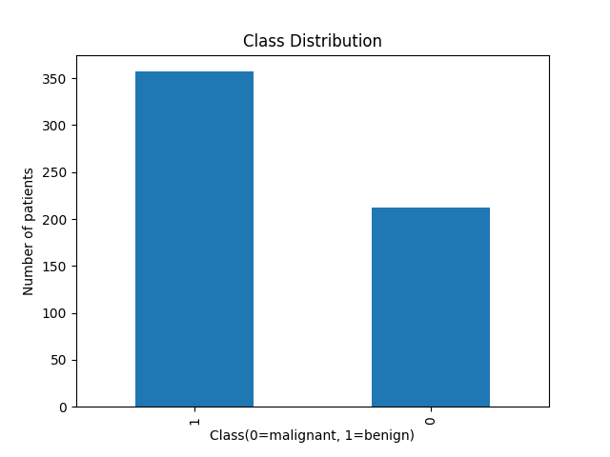Breast Cancer
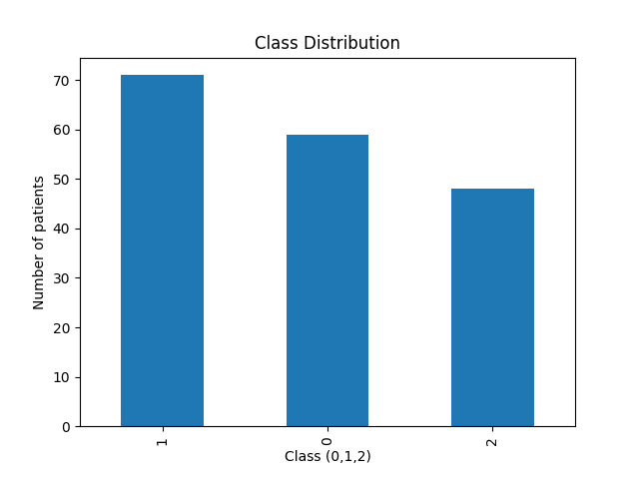Wine
I also drew a Pearson correlation heatmap for each dataset. In Breast Cancer, the three strongest pairs were mean radius – mean perimeter, worst radius – worst perimeter and mean radius – mean area (all about 0.99). This makes sense because radius, perimeter and area all measure the size of the cell nucleus. In Wine, the three strongest pairs were total_phenols – flavanoids (about 0.86), flavanoids – od280/od315_of_diluted_wines (about 0.79) and total_phenols – od280/od315_of_diluted_wines (about 0.70). Flavanoids are a type of phenol, so it is normal that they go up together.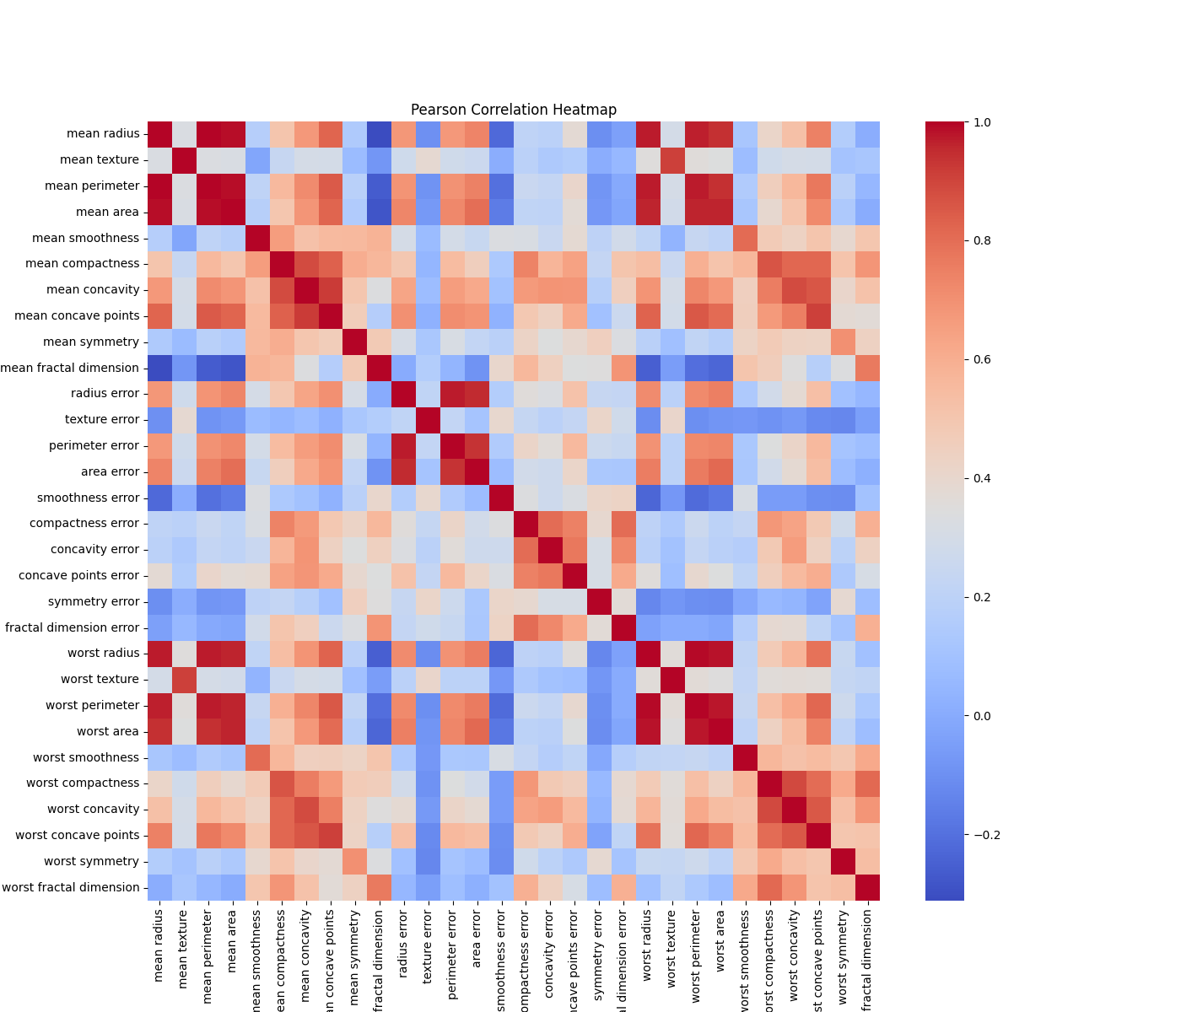
Correlation heatmap – Breast Cancer

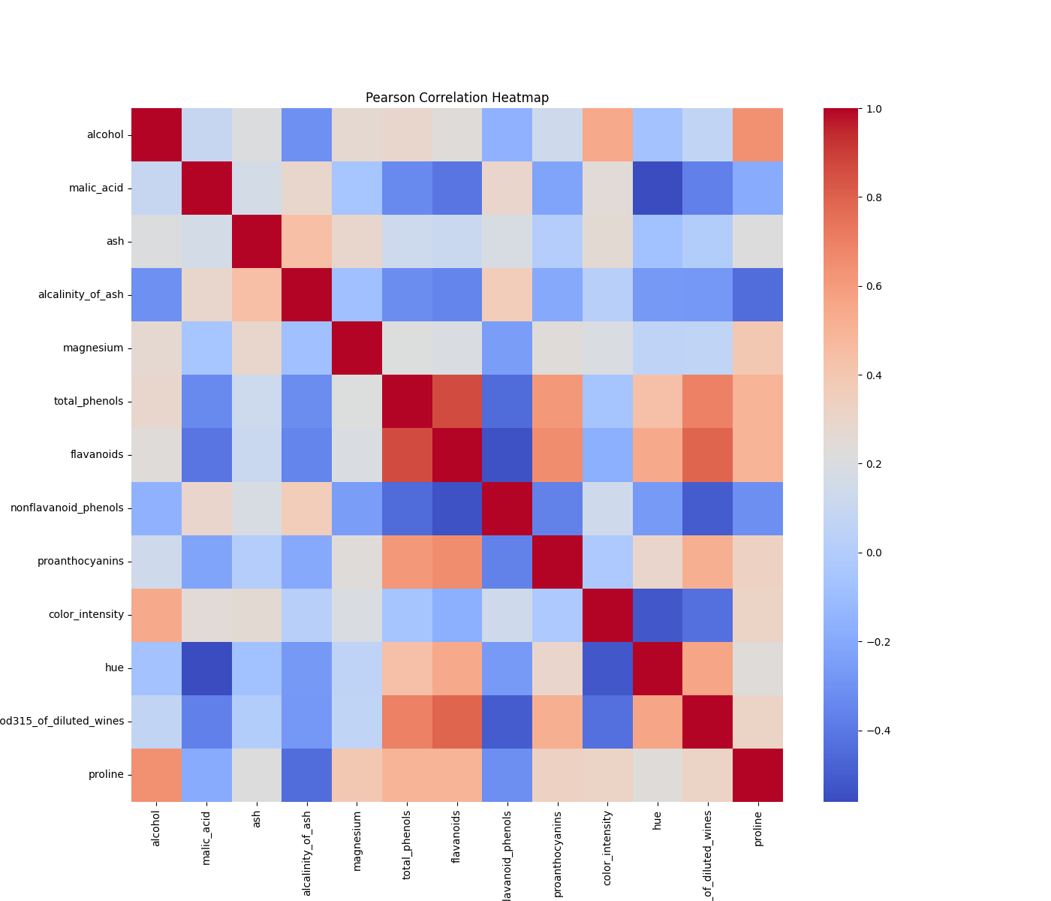
Correlation heatmap – Wine

3.3 Boxplots
I drew a boxplot for every feature. I put each feature in its own small plot, because the scales are very different. Two things I noticed:
- The ranges are very different. For example, the area features in Breast Cancer and proline in Wine have much bigger values than the other features.
- Most outliers are on the top side of the boxes. In Breast Cancer the area and radius features have many outliers, and in Wine magnesium, alcalinity_of_ash, malic_acid and color_intensity have some outliers.
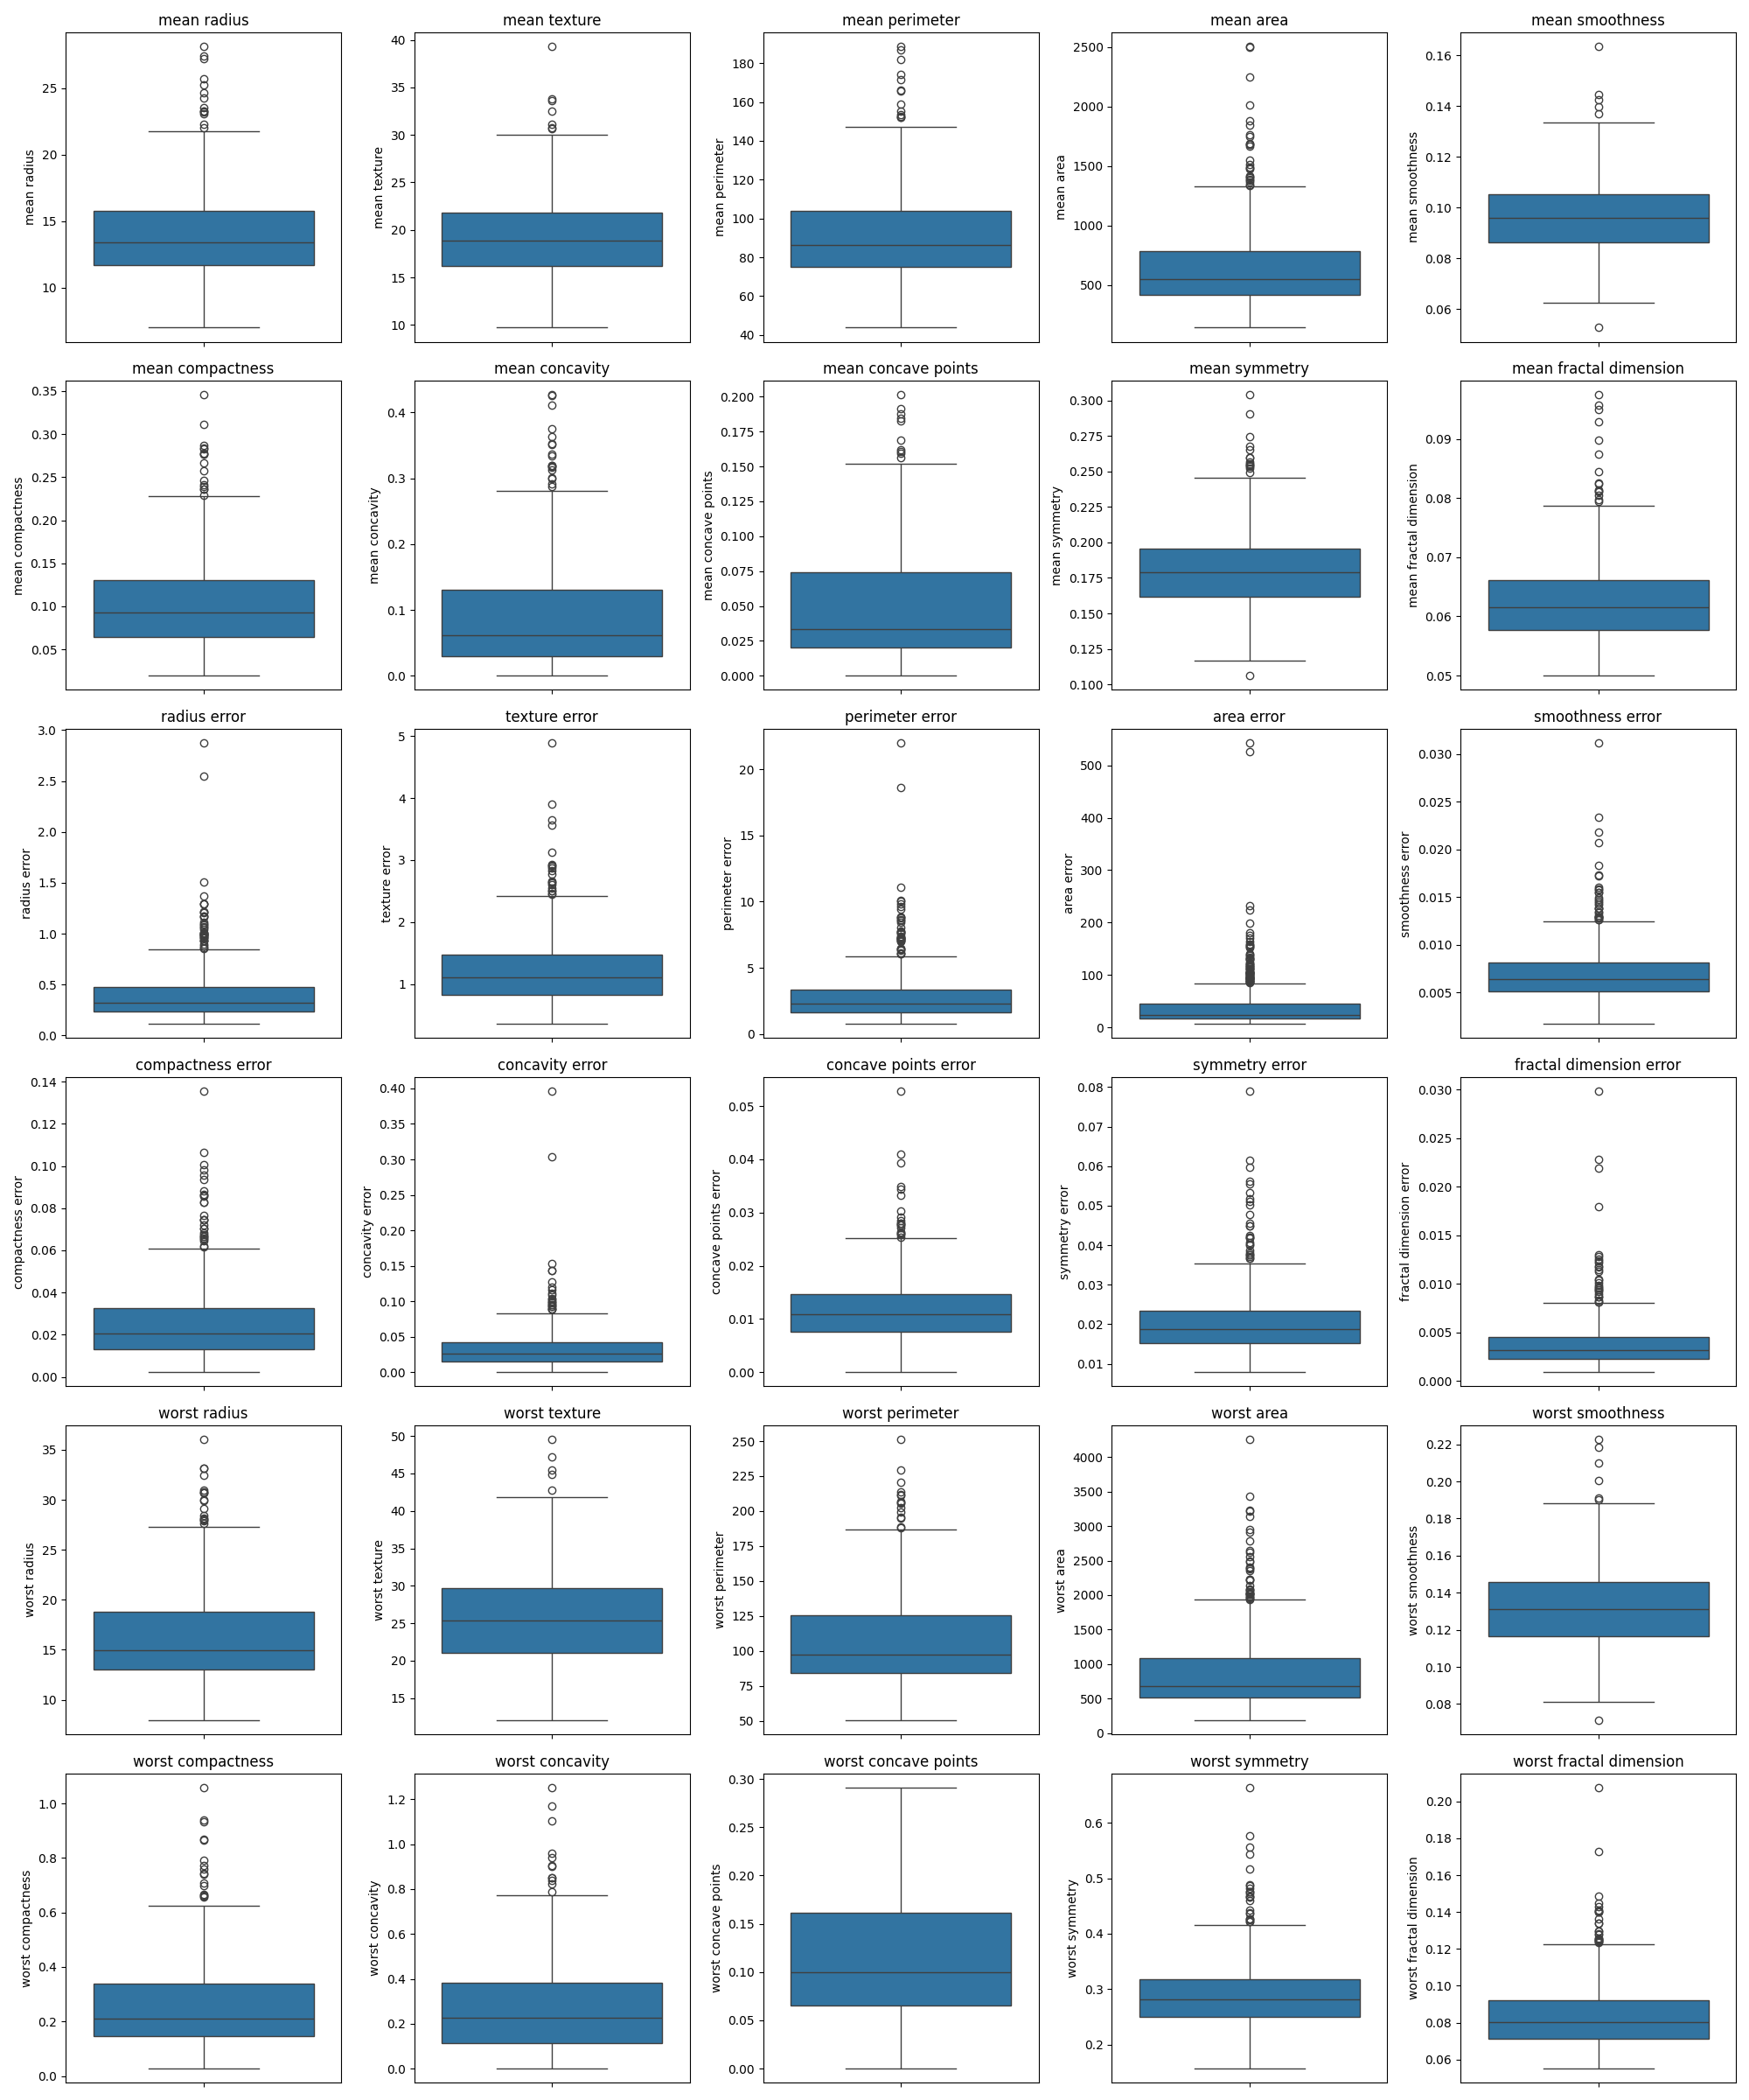
Boxplots – Breast Cancer

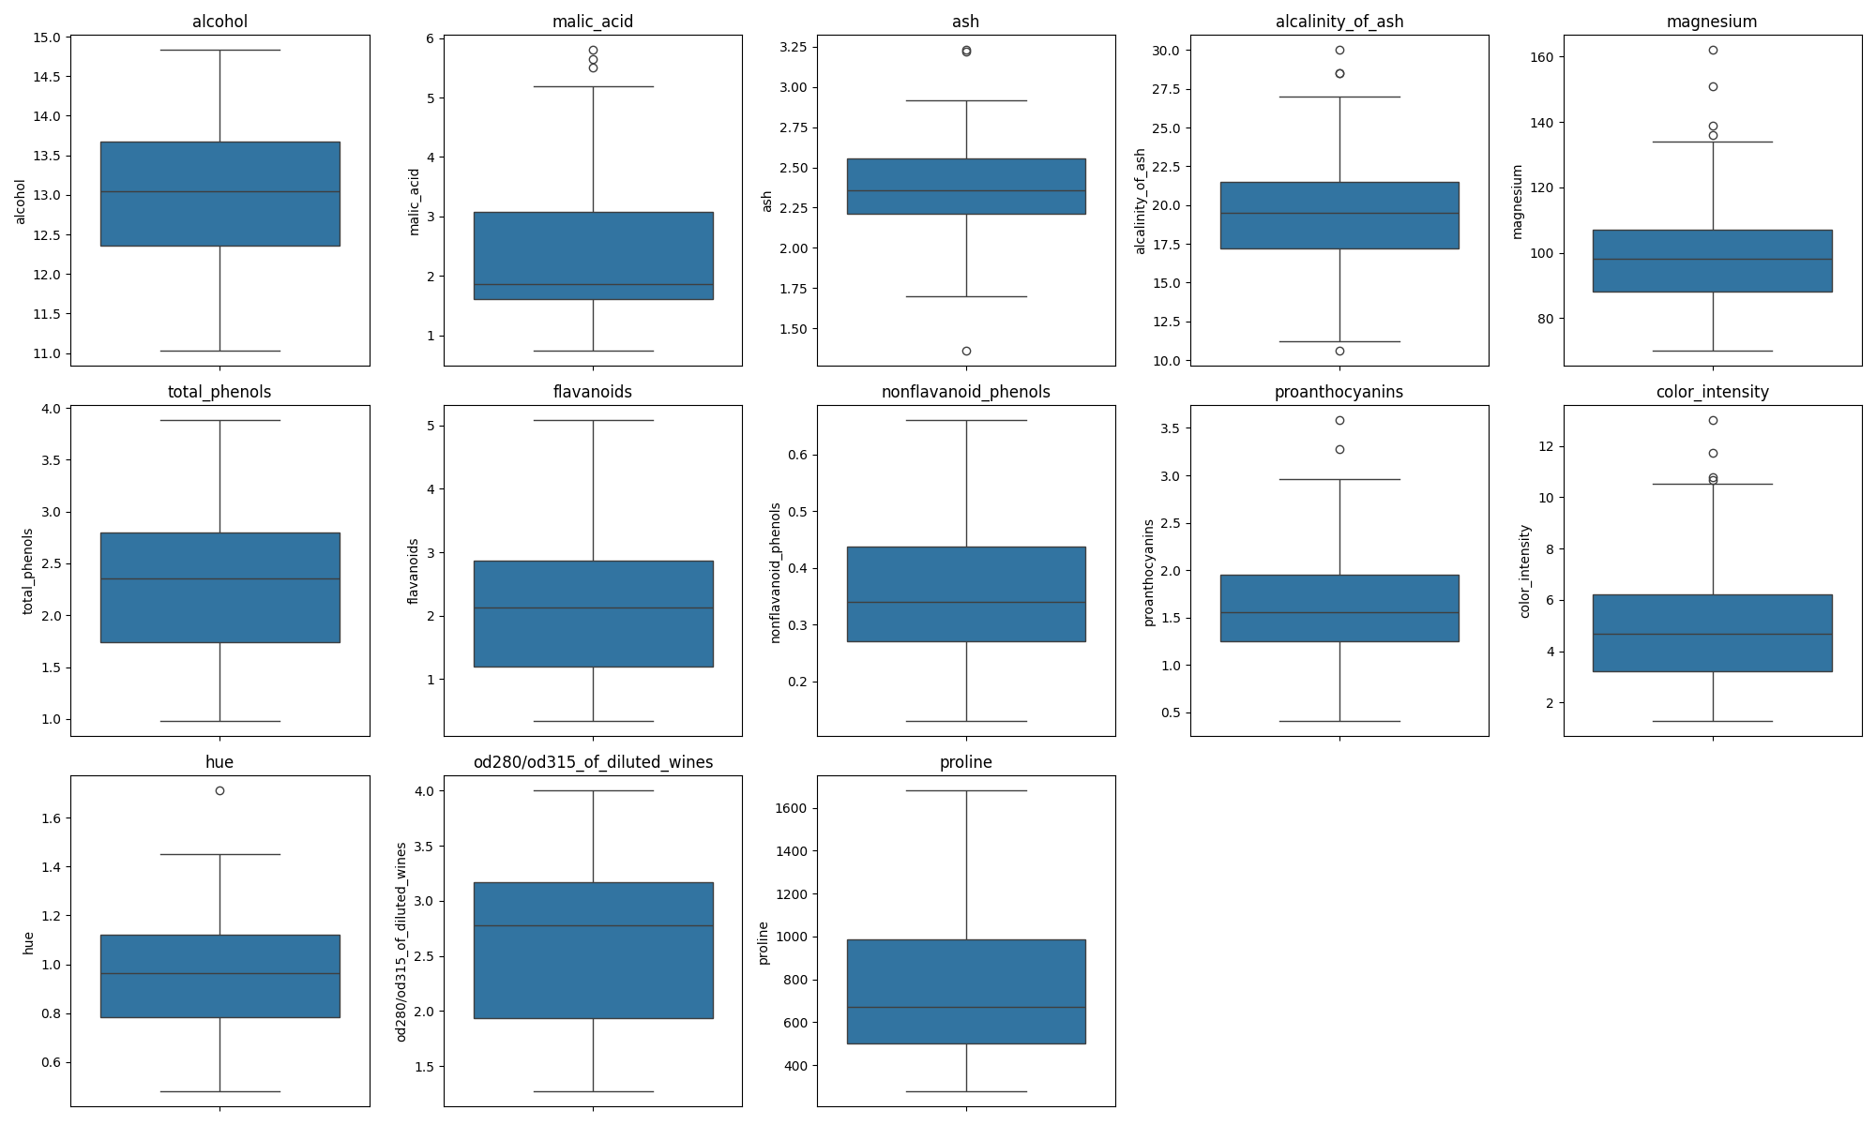
Boxplots – Wine
These summaries were only used to understand the data. I did not use them to choose features, fit any preprocessing or remove samples.

4. Splitting the Datasets
First, I kept 20% of each dataset as a test set. I did this only one time with random_state = 42 and stratify, and I never changed these test samples. Then I split the other 80% into training and validation three times, using the seeds 42, 52 and 62 (test_size = 0.125, so about 70% train and 10% validation of the whole data). I used stratify here too, so the class ratios stay almost the same in every part.
The seeds only change which samples go to train and which go to validation. The test set is the same in all three seeds. I checked every split: there is no sample in two parts at the same time, and the parts add up to the full dataset.
Dataset | Train | Validation | Test | Total
Breast Cancer | 398 (69.9%) | 57 (10.0%) | 114 (20.0%) | 569
Wine | 124 (69.7%) | 18 (10.1%) | 36 (20.2%) | 178
Split sizes (the same for seeds 42, 52 and 62)

5. Data Preprocessing and Scaling
There were no missing values, so I did not need imputation. I chose StandardScaler for both datasets and all seeds. It changes every feature so that its mean is 0 and its standard deviation is 1. This way, big features like area and proline do not control the distance calculations.
I created a new scaler for every dataset and seed, so 6 scalers in total. Each scaler was fitted only on its own training data. Then I used it to transform the training and validation data. For the final test, I transformed the test data with the scaler of seed 42. I never fitted a scaler on validation or test data, so no information from them leaked into the models. After scaling, the values of all features were roughly between -3 and +3.

6. Preparing the Two Data Representations
For every dataset and seed I kept two versions of the data: unscaled (original values) and scaled (after StandardScaler). Both versions have exactly the same samples. I trained every model on both versions, so I could see the effect of scaling.

7. Training the Classification Models
I used three classification models:
- Decision Tree with max_depth = 2, 3, 5, 10 and None (random_state = seed)
- KNN with n_neighbors = 1, 3, 5, 7 and 11 (uniform weights, Euclidean distance)
- Gaussian Naive Bayes with default settings
That is 11 settings. I ran each setting on both versions of the data and with all three seeds, so 11 x 2 x 3 = 66 runs for each dataset and 132 runs in total. Every model was trained only on the training data. For each run I saved the training accuracy and training macro F1, and the five validation metrics. Each run has an ID like wine_knn_scaled_k5_s42. I kept the seed 42 models for the final test. I used loops and functions for this, not copied cells.

8. Measuring Validation Performance
config_id | train_f1_mean | val_accuracy_mean | val_f1_mean | val_f1_std | val_roc_auc_mean
bc_dt_scaled_d10 | 1.0 | 0.924 | 0.919 | 0.011 | 0.927
bc_dt_scaled_d2 | 0.953 | 0.918 | 0.912 | 0.024 | 0.922
bc_dt_scaled_d3 | 0.974 | 0.924 | 0.918 | 0.03 | 0.941
bc_dt_scaled_d5 | 0.995 | 0.924 | 0.919 | 0.023 | 0.93
bc_dt_scaled_dNone | 1.0 | 0.924 | 0.919 | 0.011 | 0.927
bc_dt_unscaled_d10 | 1.0 | 0.924 | 0.919 | 0.011 | 0.927
bc_dt_unscaled_d2 | 0.953 | 0.918 | 0.912 | 0.024 | 0.922
bc_dt_unscaled_d3 | 0.974 | 0.924 | 0.918 | 0.03 | 0.941
bc_dt_unscaled_d5 | 0.995 | 0.924 | 0.919 | 0.023 | 0.93
bc_dt_unscaled_dNone | 1.0 | 0.924 | 0.919 | 0.011 | 0.927
bc_gnb_scaled_default | 0.931 | 0.93 | 0.925 | 0.02 | 0.976
bc_gnb_unscaled_default | 0.932 | 0.942 | 0.937 | 0.023 | 0.98
bc_knn_scaled_k1 | 1.0 | 0.942 | 0.937 | 0.021 | 0.934
bc_knn_scaled_k11 | 0.969 | 0.965 | 0.961 | 0.039 | 0.994
bc_knn_scaled_k3 | 0.979 | 0.959 | 0.955 | 0.023 | 0.979
bc_knn_scaled_k5 | 0.972 | 0.959 | 0.955 | 0.023 | 0.979
bc_knn_scaled_k7 | 0.97 | 0.971 | 0.968 | 0.03 | 0.978
bc_knn_unscaled_k1 | 1.0 | 0.889 | 0.879 | 0.057 | 0.876
bc_knn_unscaled_k11 | 0.94 | 0.924 | 0.916 | 0.011 | 0.961
bc_knn_unscaled_k3 | 0.956 | 0.901 | 0.891 | 0.045 | 0.93
bc_knn_unscaled_k5 | 0.947 | 0.918 | 0.911 | 0.03 | 0.948
bc_knn_unscaled_k7 | 0.944 | 0.912 | 0.904 | 0.001 | 0.958

config_id | train_f1_mean | val_accuracy_mean | val_f1_mean | val_f1_std | val_roc_auc_mean
wine_dt_scaled_d10 | 1.0 | 0.944 | 0.946 | 0.055 | 0.955
wine_dt_scaled_d2 | 0.936 | 0.852 | 0.848 | 0.036 | 0.905
wine_dt_scaled_d3 | 0.993 | 0.944 | 0.946 | 0.055 | 0.961
wine_dt_scaled_d5 | 1.0 | 0.944 | 0.946 | 0.055 | 0.955
wine_dt_scaled_dNone | 1.0 | 0.944 | 0.946 | 0.055 | 0.955
wine_dt_unscaled_d10 | 1.0 | 0.944 | 0.946 | 0.055 | 0.955
wine_dt_unscaled_d2 | 0.936 | 0.852 | 0.848 | 0.036 | 0.905
wine_dt_unscaled_d3 | 0.993 | 0.944 | 0.946 | 0.055 | 0.961
wine_dt_unscaled_d5 | 1.0 | 0.944 | 0.946 | 0.055 | 0.955
wine_dt_unscaled_dNone | 1.0 | 0.944 | 0.946 | 0.055 | 0.955
wine_gnb_scaled_default | 0.984 | 0.963 | 0.964 | 0.031 | 1.0
wine_gnb_unscaled_default | 0.984 | 0.963 | 0.964 | 0.031 | 1.0
wine_knn_scaled_k1 | 1.0 | 0.963 | 0.966 | 0.03 | 0.975
wine_knn_scaled_k11 | 0.966 | 0.981 | 0.981 | 0.032 | 1.0
wine_knn_scaled_k3 | 0.969 | 0.944 | 0.946 | 0.056 | 1.0
wine_knn_scaled_k5 | 0.976 | 0.981 | 0.981 | 0.032 | 1.0
wine_knn_scaled_k7 | 0.96 | 0.981 | 0.981 | 0.032 | 1.0
wine_knn_unscaled_k1 | 1.0 | 0.704 | 0.671 | 0.023 | 0.765
wine_knn_unscaled_k11 | 0.731 | 0.63 | 0.6 | 0.001 | 0.822
wine_knn_unscaled_k3 | 0.829 | 0.667 | 0.646 | 0.043 | 0.833
wine_knn_unscaled_k5 | 0.774 | 0.704 | 0.667 | 0.04 | 0.864
wine_knn_unscaled_k7 | 0.78 | 0.667 | 0.636 | 0.032 | 0.846

8.1 Required metrics
For every run I calculated five metrics on the validation data: accuracy, macro precision, macro recall, macro F1 and ROC-AUC. Macro means that the score is calculated for each class and then the simple average is taken, so every class has the same importance. For Breast Cancer, ROC-AUC uses malignant (class 0) as the positive class and the predicted probability of class 0. For Wine, ROC-AUC is one-vs-rest with macro average, also calculated from probabilities. When a class was never predicted, precision is not defined. I used zero_division = 0 for this and I wrote these cases in the run table.
8.2 Comparison tables and model selection
I grouped the 66 runs of each dataset by algorithm, representation and parameter. This gives 22 configurations. For each one I calculated the mean and the sample standard deviation over the three seeds. Tables 3 and 4 show these summaries.
I chose one configuration for each dataset with the highest mean validation macro F1. If there was a tie, I looked at mean validation accuracy, then the lower F1 standard deviation, then the alphabetical ID. I did not look at the test data for this.
- Breast Cancer: bc_knn_scaled_k7, mean validation F1 = 0.968 (std 0.030)
- Wine: wine_knn_scaled_k11, mean validation F1 = 0.981 (std 0.032). In Wine, scaled KNN with k = 5, 7 and 11 had the same mean F1, so the tie rules chose k = 11.
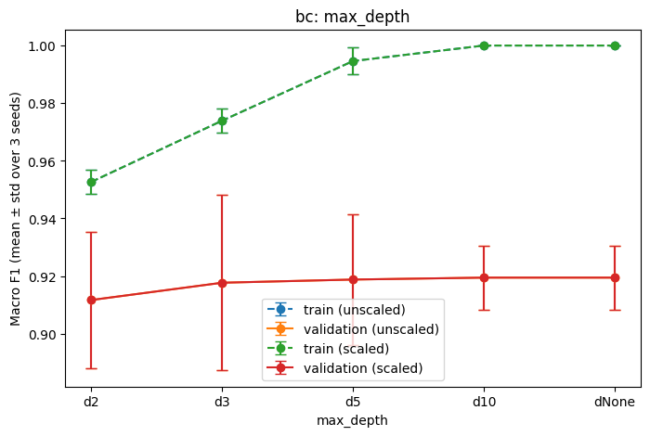
Decision Tree max_depth – Breast Cancer

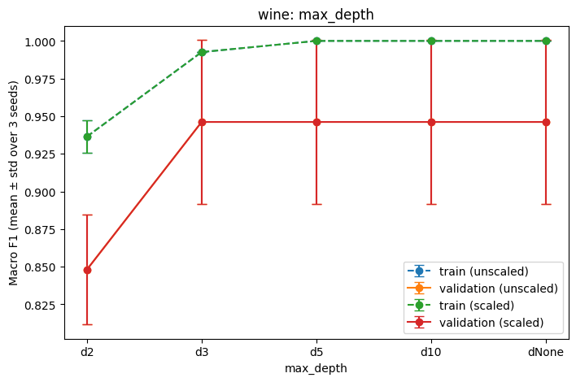
Decision Tree max_depth – Wine

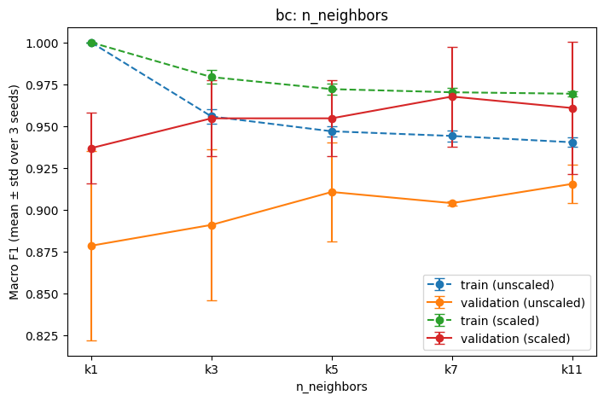
KNN n_neighbors – Breast Cancer
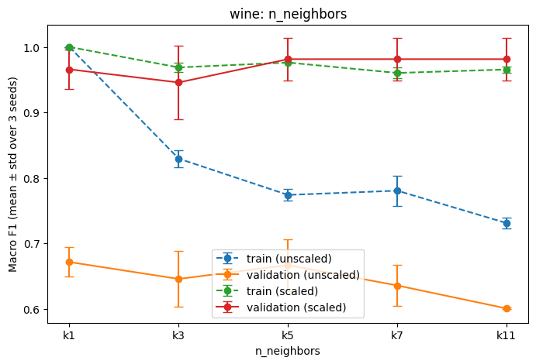
KNN n_neighbors – Wine
Effect of scaling. Scaling changed KNN the most. In Breast Cancer, KNN with k = 7 went from 0.904 (unscaled) to 0.968 (scaled) mean validation F1. In Wine the change was much bigger: unscaled KNN was only between 0.60 and 0.67, but scaled KNN was between 0.95 and 0.98. This is because proline in Wine and the area features in Breast Cancer are very big, so without scaling they control the distance. Decision Tree gave exactly the same results with and without scaling, so in the figures the unscaled lines are hidden under the scaled lines. Naive Bayes changed only a little.
Tree depth and number of neighbours. When the tree gets deeper, training F1 goes up to 1.0, but validation F1 does not follow. In Breast Cancer it stayed around 0.91–0.92 and in Wine it stayed around 0.95 after depth 3. So deeper trees mostly memorize the training data (overfitting). For KNN, a bigger k did not always help. In Breast Cancer the best was k = 7 and k = 11 was a bit lower. In Wine, k = 3 was lower than k = 1, and k = 5, 7 and 11 were the same. With k = 1, training F1 is always 1.0, because the closest neighbour of a training sample is itself.
Variation across seeds. The standard deviations are between about 0.01 and 0.06. The validation sets are small (57 and 18 samples), so the result depends a bit on which samples are in validation. This standard deviation only shows the change over these three splits. It is not a confidence interval or a proof of significance.

9. Evaluating the Selected Models on the Test Sets
 | Breast Cancer | Wine
Selected configuration | bc_knn_scaled_k7 | wine_knn_scaled_k11
Evaluation seed | 42 | 42
Val F1 (mean ± std) | 0.968 ± 0.030 | 0.981 ± 0.032
Test accuracy | 0.974 | 1.000
Test macro precision | 0.980 | 1.000
Test macro recall | 0.964 | 1.000
Test macro F1 | 0.971 | 1.000
Test ROC-AUC | 0.989 | 1.000
9.1 Final performance metrics
After I chose the two models using only validation results, I tested only the seed 42 model of each selected configuration on the fixed test set, one time. I used the same seed 42 scaler. I did not train the models again and I did not test other models. Table 5 shows the results.
For Breast Cancer, the test macro F1 is 0.971 and the mean validation F1 was 0.968, so they are very close. For Wine, all test metrics are 1.0 and the mean validation F1 was 0.981, which is also close. I did not change any model after seeing the test results.
9.2 Confusion matrices
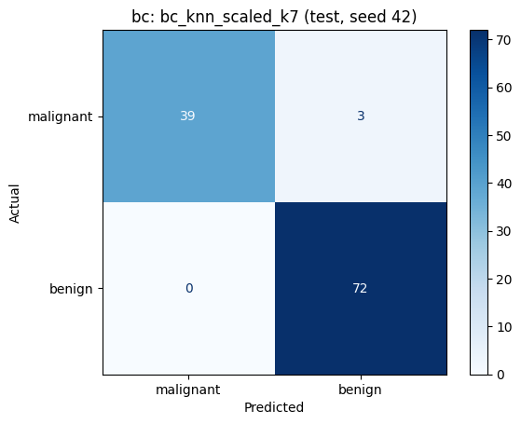
Confusion matrix – Breast Cancer (test)
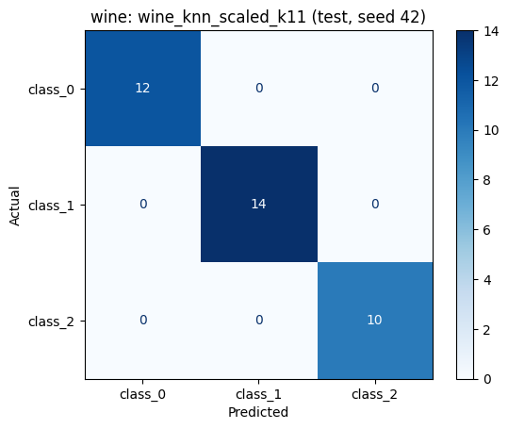
Confusion matrix – Wine (test)
In both matrices, rows are the actual classes and columns are the predicted classes. In Breast Cancer the order is [malignant, benign], and malignant is the positive class. So the top left cell is TP, top right is FN, bottom left is FP and bottom right is TN. This is different from the usual layout.
- TP = 39: malignant cases predicted as malignant
- FN = 3: malignant cases predicted as benign
- FP = 0: benign cases predicted as malignant
- TN = 72: benign cases predicted as benign
I calculated the malignant scores by hand:
- precision = 39 / (39 + 0) = 1.000
- recall = 39 / (39 + 3) = 0.929
- F1 = 2 x 1.000 x 0.929 / (1.000 + 0.929) = 0.963
These are the same as the malignant row in the classification report (not the macro average).
In Wine, the matrix has 12, 14 and 10 on the diagonal and 0 everywhere else, so there are no errors and no class was confused with another one. I chose class 1 for the hand calculation (class 1 vs the other classes): TP = 14, FN = 0, FP = 0. So precision = 14 / 14 = 1.0, recall = 14 / 14 = 1.0 and F1 = 1.0. These are the same as the class_1 row in the classification report.

9.3 ROC curves
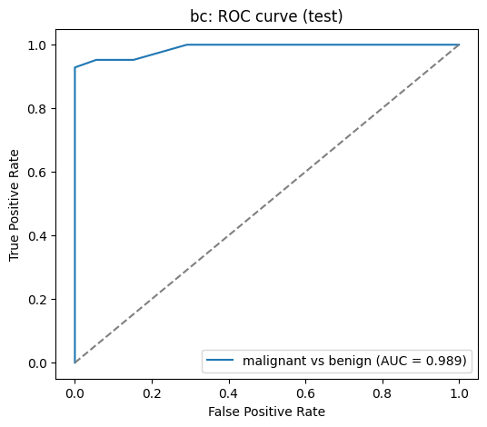
ROC curve – Breast Cancer (malignant vs benign)

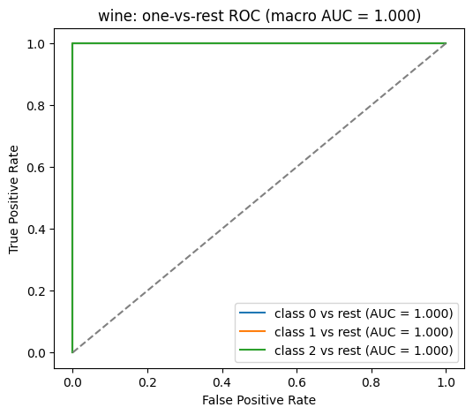
One-vs-rest ROC curves – Wine
For Breast Cancer, the ROC curve is very close to the top left corner and the AUC is 0.989. For Wine, I drew one curve for each class (one-vs-rest). All three class AUCs are 1.0, and the macro AUC is also 1.0.
The model gives a probability for each class, and a threshold decides the final class. If we make the threshold lower for malignant, the model says “malignant” more often. Then false negatives go down, but false positives go up. If we make the threshold higher, the opposite happens. I did not change the threshold and I did not tune anything with the test set. The ROC curves are only for showing the results.
9.4 Error interpretation
In Breast Cancer, the model made 3 mistakes, and all of them are the same type: malignant cases predicted as benign (false negatives). For example, test sample 41 is malignant, but its mean radius (10.95) and mean area (371.1) are small, like benign cases. So the closest neighbours of this sample were mostly benign, and KNN predicted benign. This type of error is the most dangerous one in medicine, because a cancer case is missed.
In Wine, the model made no mistakes on the test set. But this does not mean the model is perfect. The test set has only 36 wines, so a perfect score can happen by chance. Also, in validation the F1 changed between seeds, so the model sometimes makes mistakes.
Limitations: the validation sets are small (57 and 18 samples), the three train/validation splits overlap so they are not independent, and I tested only one model that I chose before testing (seed 42). So the test results are only one result for each dataset, not a proof.
10. K-Means Clustering
Dataset | Representation | Val ARI (mean ± std) | Val silhouette (mean ± std) | Valid silhouette count
Breast Cancer | unscaled | 0.504 ± 0.106 | 0.677 ± 0.033 | 3
Breast Cancer | scaled | 0.581 ± 0.142 | 0.312 ± 0.055 | 3
Wine | unscaled | ___ | ___ | ___
Wine | scaled | ___ | ___ | ___
K-Means validation summary (mean and std over 3 seeds)

Dataset | Representation | Test cluster counts | Test ARI | Test silhouette
Breast Cancer | unscaled | 86 / 28 | 0.558 | 0.712
Breast Cancer | scaled | 74 / 40 | 0.735 | 0.325
Wine | unscaled | 14 / 10 / 12 | 0.373 | 0.493
Wine | scaled | 13 / 13 / 10 | 0.909 | 0.271

K-Means test results (seed 42 models)

10.1 Fit the clustering model
I used K-Means on both datasets, on both versions (unscaled and scaled) and with all three seeds, so 12 K-Means fits in total. I fitted K-Means only on the training features and I did not give it the labels (y). I used n_clusters = 2 for Breast Cancer and 3 for Wine, because these are the class counts. I also used random_state = seed and n_init = 10. After fitting, I used predict on the validation data and calculated ARI and silhouette. Table 6 shows the mean and standard deviation over the seeds.
In both datasets, the scaled version had a higher validation ARI than the unscaled version, so after scaling the clusters are more similar to the real classes. I did not compare inertia between scaled and unscaled data, because the values are in different units.
10.2 Final cluster evaluation on the fixed test sets
For the final evaluation I used the seed 42 K-Means models and predicted the test clusters, without fitting again. Table 7 shows the results.
In Breast Cancer, the real test set has 42 malignant and 72 benign samples. Unscaled K-Means made clusters of 86 and 28 (ARI 0.558), and scaled K-Means made clusters of 74 and 40 (ARI 0.735). In Wine, the real test set has 12, 14 and 10 wines. Unscaled K-Means had ARI 0.373, but scaled K-Means had ARI 0.909, which is very close to the real classes.
In the contingency tables, the unscaled versions mix the classes a lot, and many samples of one class go to the wrong cluster. In the scaled versions, most samples of each class are in one cluster. The cluster numbers are not the same as the class numbers, so I did not calculate accuracy. I only used ARI, which compares the two groupings and does not care about the numbers.
The silhouette scores are higher in the unscaled versions, but this does not mean they are better. Silhouette depends on the feature space, and in the unscaled data one or two big features (area, proline) control the distance.

10.3 Visualise and interpret the clusters
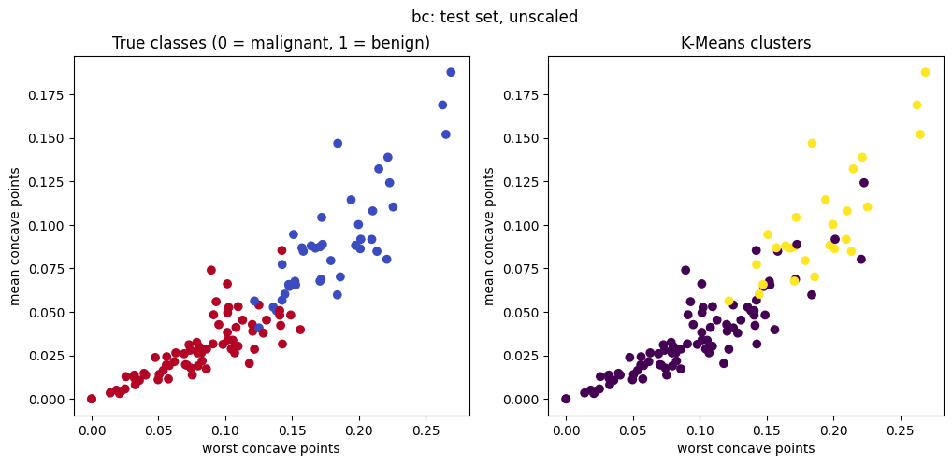
K-Means – Breast Cancer, unscaled (test)

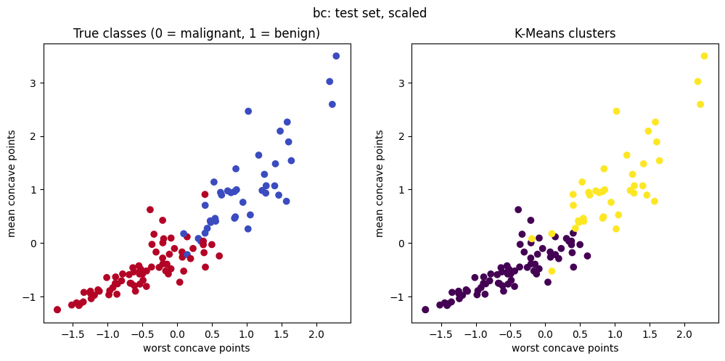
K-Means – Breast Cancer, scaled (test)

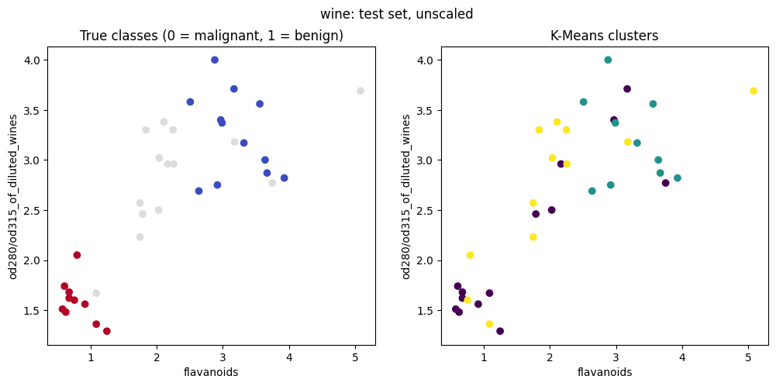
K-Means – Wine, unscaled (test)

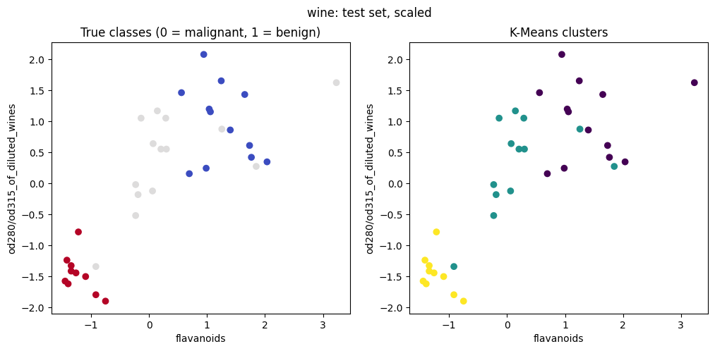
K-Means – Wine, scaled (test)
For the plots I chose the two features that have the strongest relation with the class in the seed 42 training data. For Breast Cancer these are worst concave points and mean concave points, and for Wine they are flavanoids and od280/od315_of_diluted_wines. The left panel shows the real classes and the right panel shows the K-Means clusters. The model used all features, so these plots only show two of them.
In the unscaled plots, the clusters do not follow the real classes well. In the scaled plots, the clusters look much more like the real classes, especially in Wine. Only some samples in the middle are in the wrong cluster.
The big difference between K-Means and the three classifiers is the information they use. Decision Tree, KNN and Naive Bayes saw the training labels (y_train) during training. K-Means never saw any labels. It only used the features. I used the labels only after clustering, to calculate ARI and to make the contingency tables.
11. Comparing the Two Datasets
Did the same classifier and representation perform best on both datasets?
Yes. In both datasets the best model was KNN on scaled data. Only the number of neighbours was different: k = 7 for Breast Cancer and k = 11 for Wine. In validation, the mean macro F1 was 0.968 for Breast Cancer and 0.981 for Wine. In the test, the macro F1 was 0.971 for Breast Cancer and 1.000 for Wine. So the same type of model was the best in both validation and test.
Which algorithm was most affected by scaling?
KNN was the most affected. In Breast Cancer, KNN with k = 7 went from 0.904 (unscaled) to 0.968 (scaled) mean validation F1, and KNN with k = 1 went from 0.879 to 0.937. In Wine the effect was much bigger: unscaled KNN was only between 0.60 and 0.67, but scaled KNN was between 0.95 and 0.98. Decision Tree had exactly the same results with and without scaling, and Naive Bayes changed very little (for example 0.937 vs 0.925 in Breast Cancer).
Did deeper trees or larger neighbour counts always improve validation performance?
No. For Decision Tree, training F1 went up to 1.0 with more depth, but validation F1 stayed around 0.91–0.92 in Breast Cancer, and in Wine it stayed around 0.95 after depth 3. For KNN, a bigger k did not always help either. In Breast Cancer the best was k = 7 and k = 11 was a bit lower. In Wine, k = 3 was lower than k = 1, and k = 5, 7 and 11 had the same score. The standard deviation across seeds was between about 0.001 and 0.06, so some results changed quite a lot between the three splits.
How did the main classification errors differ between the two datasets?
In Breast Cancer, the model made 3 errors in the test set, and all of them were malignant cases predicted as benign (false negatives). There were no false positives. In Wine, the model made no errors in the test set. So in Breast Cancer the errors were all of the most dangerous type, while in Wine there were no errors at all.
How did K-Means agreement with the true classes differ between datasets?
With scaling, K-Means found the classes better in Wine (test ARI 0.909) than in Breast Cancer (test ARI 0.735). Without scaling, it was the opposite: Breast Cancer had ARI 0.558 and Wine only 0.373. The contingency tables show the same thing. In scaled Wine, most wines of each class are in one cluster, but in Breast Cancer more samples are mixed. ARI is not accuracy, it only shows how similar the two groupings are.
What one change would I try next?
As future work, I would try k-fold cross-validation instead of three overlapping train/validation splits. The validation sets are very small (57 and 18 samples), so the model choice depends a bit on luck. Cross-validation would use all training data for validation in turns and would give a more reliable result.
Appendix: Descriptive statistics
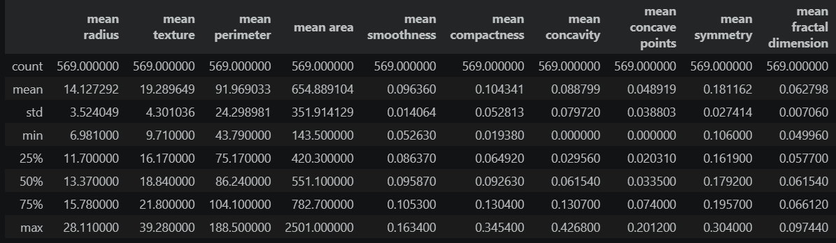
Descriptive statistics – Breast Cancer

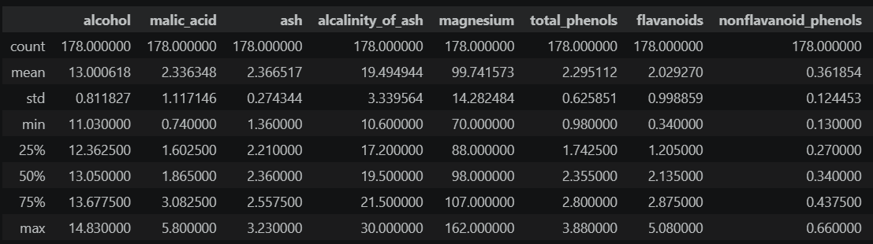
Descriptive statistics – Wine

GitHub repository: https://github.com/ravzakoc8/machine_learning
Video: https://youtu.be/FrsO97Y5hes?si=gWi1rqEIsBSngOL0

